Department of Computer Science and Engineering (Data Science)
CSDS-A | Batch A3 (CSE - Data Science, Section A)
A Dynamic Phishing URL Detection System Integrating Advanced Machine Learning and Crowdsourced Threat Intelligence
(PhishGuard)
S.No. | Student name | Roll / hall ticket no.
1 | D.ANISH MEGHAN | 23K91A6750
2 | B.AKSHAYA | 23K91A6737
3 | B.TANUJA | 23K91A6736
4 | CH.SAI CHETHAN | 23K91A6742
Under the guidance of: Mr. G. Ravi, [DESIGNATION]
CONCLUSION, FUTURE SCOPE AND REFERENCES
This document concludes the project: what was achieved, the key findings, the known limitations, concrete future work, and the numbered list of references.

1 Summary of the Work
This project built PhishGuard, an adaptive phishing URL detection system that follows the three-stage design of the base paper: extract features from a URL, classify it with machine learning, and refine the system with crowdsourced threat intelligence. A balanced sample of 40,000 labelled URLs was cleaned and turned into 47 offline features; Random Forest, XGBoost and Logistic Regression were compared on the same split; and XGBoost was selected with accuracy 92.93 %, F1 92.88 % and ROC-AUC 0.981 on 8,000 held-out URLs, and F1 92.56 % in 5-fold cross-validation.
Around the classifier, the project built a community store in which two net votes, or one trusted feed report, confirm a URL; a confirmed verdict, phishing or safe, overrides the model at once; and confirmed URLs are folded into the training data by a retraining loop that reloads the new model without a restart. A Flask API, a command-line interface and a seven-page React interface make the whole pipeline usable.

2 Objectives Achieved
Table 1: Objectives and their status
Objective | Achieved? | Note
1. Collect and preprocess a dataset | Yes | 40,000 URLs from a public set; one source
2. Extract lexical, structural and domain features | Yes | 47 features, 3 groups, red flags
3. Train and compare RF, XGBoost, LR | Yes | XGBoost F1 92.88 %; LR is clearly weaker
4. Integrate crowdsourced threat intelligence | Yes | Consensus, trusted feeds, community-first decisions; no administrator review
5. Refine the model continuously | Mechanism: yes; effect: not measurable here | Retrain and hot reload run end to end; no gain on in-distribution data
6. Real-time classification with a web interface | Yes | Mean API check 8.0 ms; no sign-in

3 Key Findings
1. Tree ensembles on 47 engineered URL features reach 92.9 % accuracy; logistic regression reaches only 82.8 %, so the problem is not linearly separable in these features.
2. Lexical features carry most of the signal (F1 89.2 % alone); structural features alone are weak; adding domain features gives the final 3 to 4 points.
3. The model does not depend on its two strongest features: removing both costs only 0.2 points of F1.
4. A well-chosen threshold matters: F1 is flat between 0.40 and 0.60, but the 0.35 suspicious band recovers 187 phishing URLs that would otherwise read as safe.
5. The community override works in both directions and takes effect immediately: a lookalike page scored 9.5 % became phishing at 97 % after two reports, and two flagged legitimate pages were cleared.
6. Retraining on random correctly labelled URLs from the same distribution does not change the average F1 (within 0.1 point); the loop's value is the override, not the average.
7. URL-only features cannot catch phishing pages on clean-looking domains, and a hand-written reputation list causes false positives on legitimate sites such as docs.python.org.
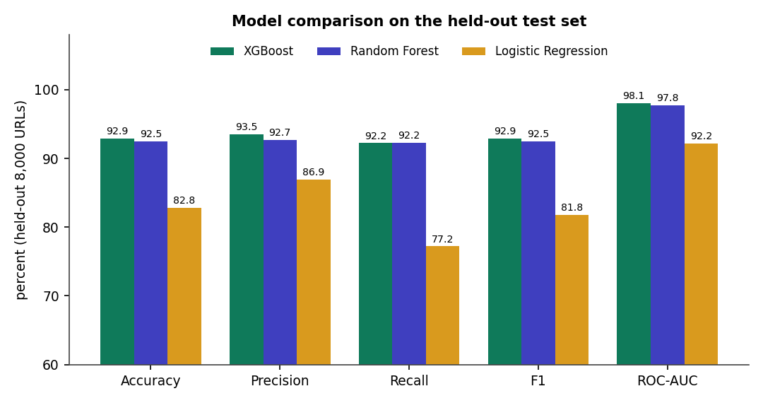
Fig. 1: Summary: the three classifiers on the held-out test set

4 Practical Applications
- A first-line link checker for a team or a small organisation, with a shared community list of confirmed phishing and safe URLs.
- A teaching tool for URL-based phishing detection: its features, red flags, thresholds and retraining are visible in the interface.
- A back end for a browser extension, a mail-gateway plug-in or a chat bot through the JSON API.
- A test bed for studying crowd-fed learning, since the consensus rule, the weight and the thresholds are single constants in config.py.

5 Known Limitations
- Small, single-source dataset; the 92.9 % accuracy is not comparable with the base paper's 99.8 %.
- URL-only features; clean-looking hosts and ordinary-looking pages are missed (311 false negatives of 4,000 phishing URLs).
- Hand-written reputation list (145 domains).
- Anonymous vote-based confirmation without sign-in, moderation, rate limiting or reporter reputation; host-wide override.
- Benefit of retraining on new campaigns not measured; v1 and v2 metrics not comparable.
- No load, concurrency or user-acceptance testing.

6 Future Scope
The items below follow from the limitations and from the base paper's own future work [1].

7 Improvements
- Evaluate on a larger and more recent dataset such as PhiUSIIL [17], and on URLs collected after the training date, to measure generalisation honestly.
- Tune the hyper-parameters and add calibration, so that the probability is a true probability and the thresholds have a principled basis.
- Replace the hand-written popular-domain list with a ranked list such as a top-sites list, and handle country-code domains.
- Make host-level override smarter: apply it to a host only after several distinct URLs are confirmed, and never to shared-hosting providers.
- Add an administrator verification queue before reports reach the training set, as the base paper does [1].

8 Additional Features
- Sign-in, roles, reporter reputation and rate limiting, so that votes can be weighted and abuse limited.
- Optional page-level features (title, form fields, redirects) fetched in a sandbox for URLs the model is unsure about.
- A browser extension and an e-mail plug-in using the existing API.
- Export of confirmed URLs as a feed, and import of further public feeds.
- A drift monitor that tracks the score distribution and recent false-positive reports.

9 Scalability and Deployment
- Move the community store from SQLite to a server database when many reporters write at once.
- Run the API behind a production WSGI server, with the model loaded once per worker and a shared reload signal.
- Cache verdicts for popular URLs and batch scoring, since the model scores 8,000 rows in about 11 ms.
- Containerise the API and the frontend for a repeatable deployment; add authentication and TLS in front.

10 Further Research
- Reproduce the base paper's LSTM-attention model on the same data and compare it with the tree ensembles under identical conditions.
- Study the crowd loop under realistic noise: simulate dishonest and careless reporters and measure how many votes the consensus needs.
- Evaluate adaptation to new campaigns with a time-split dataset or a live feed, which this static sample could not do.
- Add explanation methods such as SHAP values to the red flags, and study their effect on user trust.
- Investigate adversarial URLs crafted to defeat the features, and countermeasures [1].

REFERENCES
References 2 to 5 are the works listed in the batch literature survey; they were recorded by title, venue and year only and were not independently retrieved, so this report does not describe their methods or results.
[1] L. Aldhuwayhi and A. Alromih, "A dynamic phishing URL detection system integrating advanced machine learning and crowdsourced threat intelligence," IEEE Access, vol. 14, pp. 88393-88404, 2026, doi: 10.1109/ACCESS.2026.3700833.
[2] "Phishing URL detection using machine learning," Journal of Advanced Research in Production and Industrial Engineering, 2023.
[3] "Real-time phishing URL detection using reinforcement learning," International Journal of Science and Research (IJSR), 2025.
[4] "Phishing URL detection using machine learning and deep learning," in Proc. 2024 IEEE World AI IoT Congress (AIIoT), 2024.
[5] "Automated phishing detection through URL analysis and machine learning," Communications on Applied Nonlinear Analysis, 2025.
[6] V. Vajrobol, B. B. Gupta and A. Gaurav, "Mutual information based logistic regression for phishing URL detection," Cyber Security and Applications, vol. 2, p. 100044, Jan. 2024, doi: 10.1016/j.csa.2024.100044.
[7] T. Etem and M. Teke, "Advanced phishing detection: Leveraging t-SNE feature extraction and machine learning on a comprehensive URL dataset," Acta Infologica, vol. 231, no. 221, pp. 213-221, 2024, doi: 10.26650/acin.1521835.
[8] S. Alnemari and M. Alshammari, "Detecting phishing domains using machine learning," Applied Sciences, vol. 13, no. 8, p. 4649, Apr. 2023, doi: 10.3390/app13084649.
[9] U. A. Butt, R. Amin, H. Aldabbas, S. Mohan, B. Alouffi and A. Ahmadian, "Cloud-based email phishing attack using machine and deep learning algorithm," Complex & Intelligent Systems, vol. 9, no. 3, pp. 3043-3070, Jun. 2023, doi: 10.1007/s40747-022-00760-3.
[10] D. Rathee and S. Mann, "Detection of e-mail phishing attacks - using machine learning and deep learning," International Journal of Computer Applications, vol. 183, no. 47, pp. 1-7, Jan. 2022, doi: 10.5120/ijca2022921868.
[11] K. S. Priya, J. Chandrika and M. P. Lakshmi, "Machine learning-based phishing website detection: a comprehensive approach for cyber security," in Proc. 5th Int. Conf. Recent Trends in Computer Science and Technology (ICRTCST), Apr. 2024, pp. 344-349, doi: 10.1109/ICRTCST61793.2024.10578472.
[12] S. Sawant, R. Savakhande, O. Sankhe and S. Tamboli, "Phishing detection by integrating machine learning and deep learning," in Proc. 11th Int. Conf. Computing for Sustainable Global Development (INDIACom), Feb. 2024, pp. 1078-1083, doi: 10.23919/INDIACom61295.2024.10499100.
[13] Z. Fan, "Detecting and classifying phishing websites by machine learning," in Proc. 3rd Int. Conf. Applied Machine Learning (ICAML), Jul. 2021, pp. 48-51, doi: 10.1109/ICAML54311.2021.00018.
[14] A. Assefa and R. Katarya, "Intelligent phishing website detection using deep learning," in Proc. 8th Int. Conf. Advanced Computing and Communication Systems (ICACCS), vol. 1, Mar. 2022, pp. 1741-1745, doi: 10.1109/ICACCS54159.2022.9785003.
[15] H. Huang, N. Sun, M. Tani, Y. Zhang, J. Jiang and S. Jha, "Unmasking disinformation: Enhancing cyber threat intelligence through crowdsourced analysis and AI-driven training," in Proc. 59th Hawaii Int. Conf. System Sciences (HICSS), 2026, pp. 6049-6058, doi: 10.24251/HICSS.2026.743.
[16] K. Lazaros, A. G. Vrahatis and S. Kotsiantis, "Human-in-the-loop artificial intelligence: A systematic review of concepts, methods, and applications," Entropy, vol. 28, no. 4, p. 377, Mar. 2026, doi: 10.3390/e28040377.
[17] A. Prasad and S. Chandra, "PhiUSIIL phishing URL (website)," UCI Machine Learning Repository, 2024, doi: 10.1016/j.cose.2023.103545.
[18] J. Ma, L. K. Saul, S. Savage and G. M. Voelker, "Beyond blacklists: Learning to detect malicious web sites from suspicious URLs," in Proc. 15th ACM SIGKDD Int. Conf. Knowledge Discovery and Data Mining, 2009, pp. 1245-1254.
[19] O. K. Sahingoz, E. Buber, O. Demir and B. Diri, "Machine learning based phishing detection from URLs," Expert Systems with Applications, vol. 117, pp. 345-357, 2019.
[20] K. Krombholz, H. Hobel, M. Huber and E. Weippl, "Advanced social engineering attacks," Journal of Information Security and Applications, vol. 22, pp. 113-122, Jun. 2015, doi: 10.1016/j.jisa.2014.09.005.
[21] L. Breiman, "Random forests," Machine Learning, vol. 45, no. 1, pp. 5-32, 2001.
[22] T. Chen and C. Guestrin, "XGBoost: A scalable tree boosting system," in Proc. 22nd ACM SIGKDD Int. Conf. Knowledge Discovery and Data Mining, 2016, pp. 785-794.
[23] F. Pedregosa et al., "Scikit-learn: Machine learning in Python," Journal of Machine Learning Research, vol. 12, pp. 2825-2830, 2011.
[24] C. E. Shannon, "A mathematical theory of communication," Bell System Technical Journal, vol. 27, no. 3, pp. 379-423, Jul. 1948.
[25] "Using machine learning to detect malicious URLs," public dataset repository (data/data.csv). [Online]. Available: https://github.com/faizann24/Using-machine-learning-to-detect-malicious-URLs
[26] OpenPhish, "Phishing feed," and abuse.ch, "URLhaus: online malware URL feed." [Online]. Available: https://openphish.com and https://urlhaus.abuse.ch
[27] Pallets Projects, "Flask documentation." [Online]. Available: https://flask.palletsprojects.com
[28] Meta Platforms, "React documentation." [Online]. Available: https://react.dev

